**I) Sequence 1 vs Sequence 1A**

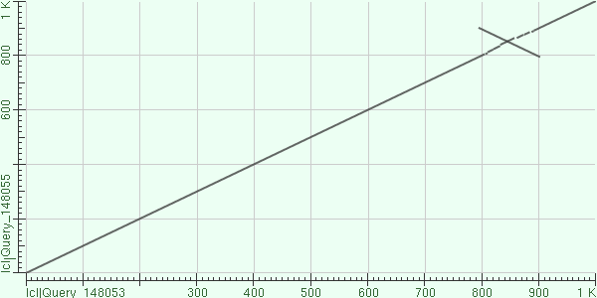

The dot plot of sequence-1 and sequence -1A represents an alignment with a high percentage of identical nucleotides at identical locations. The perpendicular anomaly that begins at roughly (800,900) represents an inversion between the sequences. At the 900th nucleotide, the sequence represented by the Y axis matches the 800th nucleotide in the sequence represented by the axis. The high percent identity and 90% identical alignment suggest homology.

**II) Sequence1 vs Sequence1B**

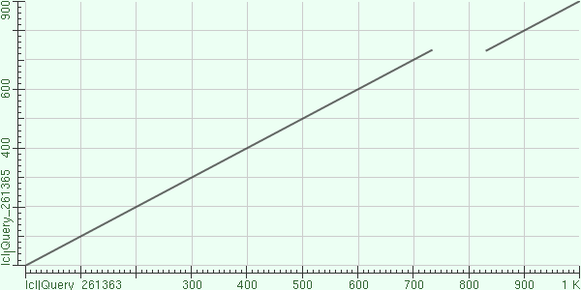

The dot plot of sequence-1 and sequence -1B represents an alignment with high a percentage of identical nucleotides at identical locations. The anomaly that begins at roughly (730,730) represents a deletion event between the sequences. The sequence represented by the Y axis is missing close to 100 nucleotides possessed by the sequence represented by the X axis. This deletion event causes a shift of the sequential location of the rest of the identical nucleotides between the sequences. Sequence X contains the same nucleotides as sequence Y separated by roughly 100 non-identical nucleotides. Despite this deletion anomaly the sequences are likely homologous due to the high percent of identical nucleotides at identical locations between the sequences.

**III) Sequence1 vs Sequence1C**

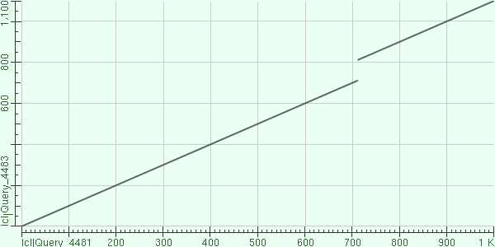

The dot plot of sequence-1 and sequence -1C represents an alignment with high percentage of identical nucleotides at identical locations between the sequences. The line represents identical nucleotides at identical locations in the sequence between the samples. The anomaly that begins at roughly (720,810) represents a deletion event between the sequences. The sequence represented by the X axis is missing close to 100 nucleotides possessed by the sequence represented by the Y axis. This deletion event causes a shift of the sequential location of the rest of the identical nucleotides between the sequences. Sequence Y is composed of the same nucleotides at the same location save for the deletion event that causes misalignment gap of roughly 100 nucleotides between the sequences. Despite this deletion anomaly, the sequences are likely homologous due to the high percent of identical nucleotides at identical locations between the sequences.

**IV) Sequence2 vs Sequence2A**

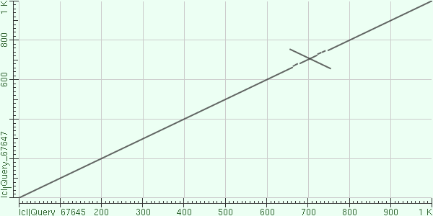

The dot plot of sequence-2 and sequence -2A represents an alignment with high percentage of identical nucleotides at identical locations between the sequences. The anomaly that begins at roughly (650,750) and is perpendicular to the identity line represents an inversion between the sequences. The 750th nucleotide of the sequence represented by the Y axis matches the 675th nucleotide of the sequence represented by the X axis. The anomaly in the dot plot represents an inversion of roughly 75 nucleotides. Despite the inversion event, the high percent identity and near perfect alignment between the sequences suggests homology.

**V) Sequence2 vs Sequence2B**

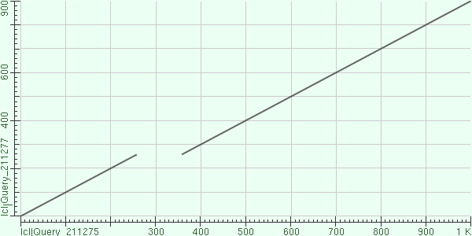

The dot plot of sequence-2 and sequence -2B represents an alignment with a high percentage of identical nucleotides at identical locations between the sequences. The anomaly that begins at roughly (720,810) represents a deletion event between the sequences. The sequence represented by the X axis has close to 100 nucleotides that are missing from the sequence represented by the Y axis. This deletion event causes a shift of the sequential location of the rest of the identical nucleotides between the sequences. Sequence X is composed of the same nucleotides at the same location save for the deletion event that causes misalignment gap of roughly 100 nucleotides between the sequences. Despite this deletion anomaly, the sequences are likely homologous due to the high percent of identical nucleotides at identical locations.